**Ideation Phase**

**Define the Problem Statements**

| Date | 19 May 2023 |
| --- | --- |
| Team ID | NM2023TMID13113 |
| Project Name | Reducing-the-Environmental-Footprint-of-Food-A-Comprehensive-Management-system |
| Maximum Marks | 2 Marks |

**Customer Problem Statement :**

**During the ideation phase of reducing the environmental footprint of food, it is crucial to define the problem statements clearly. Here are some problem statements that can be addressed:**

**Inefficient Agricultural Practices: Conventional farming methods often rely heavily on synthetic fertilizers, pesticides, and excessive water usage, leading to soil degradation, water pollution, and high energy consumption.**

**Food Waste Generation: Throughout the food supply chain, significant amounts of food are wasted due to inefficient storage, handling, transportation, and consumer behavior. Food waste contributes to greenhouse gas emissions and inefficient resource utilization.**

**High Energy Consumption: Food production, processing, and distribution are energy-intensive processes that heavily rely on fossil fuels. This reliance contributes to carbon emissions and climate change.**

**Water Scarcity and Pollution: Agriculture accounts for a significant portion of global freshwater usage. Inefficient irrigation techniques and chemical runoff from agricultural activities contribute to water scarcity and pollution.**

**Deforestation and Habitat Loss: Expanding agricultural land, particularly for livestock production, leads to deforestation, which reduces biodiversity, releases stored carbon, and contributes to climate change.**

**Unsustainable Packaging: Traditional packaging materials, such as plastics and Styrofoam, have negative environmental impacts, including pollution, resource depletion, and poor biodegradability.**

**Lack of Consumer Awareness: Many consumers are not aware of the environmental impacts of their food choices or how to make sustainable choices. This contributes to unsustainable consumption patterns, excessive food waste, and inefficient resource utilization.**

**Limited Collaboration and Knowledge Sharing: There is often a lack of collaboration and knowledge sharing among stakeholders in the food industry, hindering the development and implementation of sustainable practices.**

**Limited Access to Sustainable Options: Consumers often face challenges in accessing and affording sustainable and locally sourced food options, limiting their ability to make environmentally friendly choices.**

**Policy and Regulatory Gaps: Inconsistent or inadequate policies and regulations related to sustainable food production, labeling, and waste management can impede progress in reducing the environmental footprint of food.**

**By defining these problem statements, it becomes easier to focus on specific areas for improvement and develop targeted solutions during the ideation and implementation phases.**

**Example:**

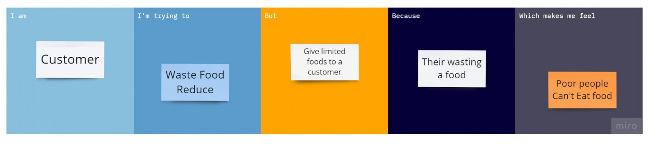

| **Problem Statement (PS)** | **I am (Customer)** | **I’m trying to** | **But** | **Because** | **Which makes me feel** |
| --- | --- | --- | --- | --- | --- |
| PS-1 | Customer | Waste food reduce | Give limited foods to a customer | Their wasting foods | Poor people can’t eat a food |
| PS-2 | Customer | Control food | Food control | Fasting | Reduce the fat |